Day4 ReVisit

Day5 Protractor

Protractor – End to End Testing Framework for Angular & AngularJS.

<https://www.protractortest.org/#/> -- Official web page

1. Installing Protractor

Npm install –g protractor

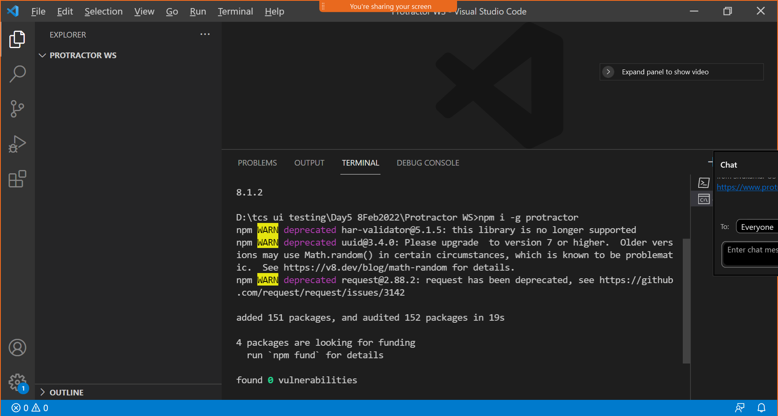

When installing protractor, WebDriver will also be installed automatically.

1. Check the version of protractor by using the following command

Protractor –version

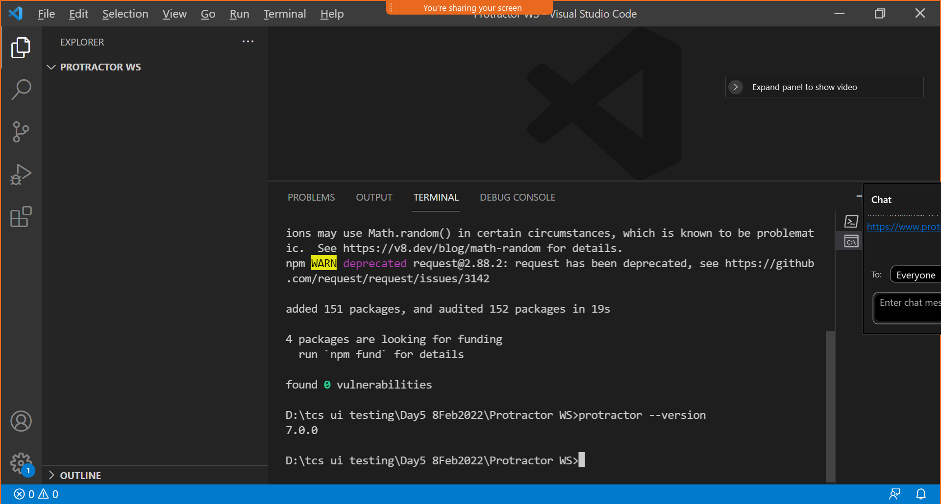

1. Web Driver Manager – This will allow Automating binary drivers mgmt. (ChromeDriver, geckoDriver..) It is needed by selenium web driver.
2. Selenium is a very popular Test automation Tool. (WebDriver, Web Recorder)
3. Web Driver Manager – (Downloads the Selenium server jar & browser drivers, run the selenium server for e2e test, manages downloaded versions)
4. Check details about webdriver manager using the following command

Webdriver-manager –help

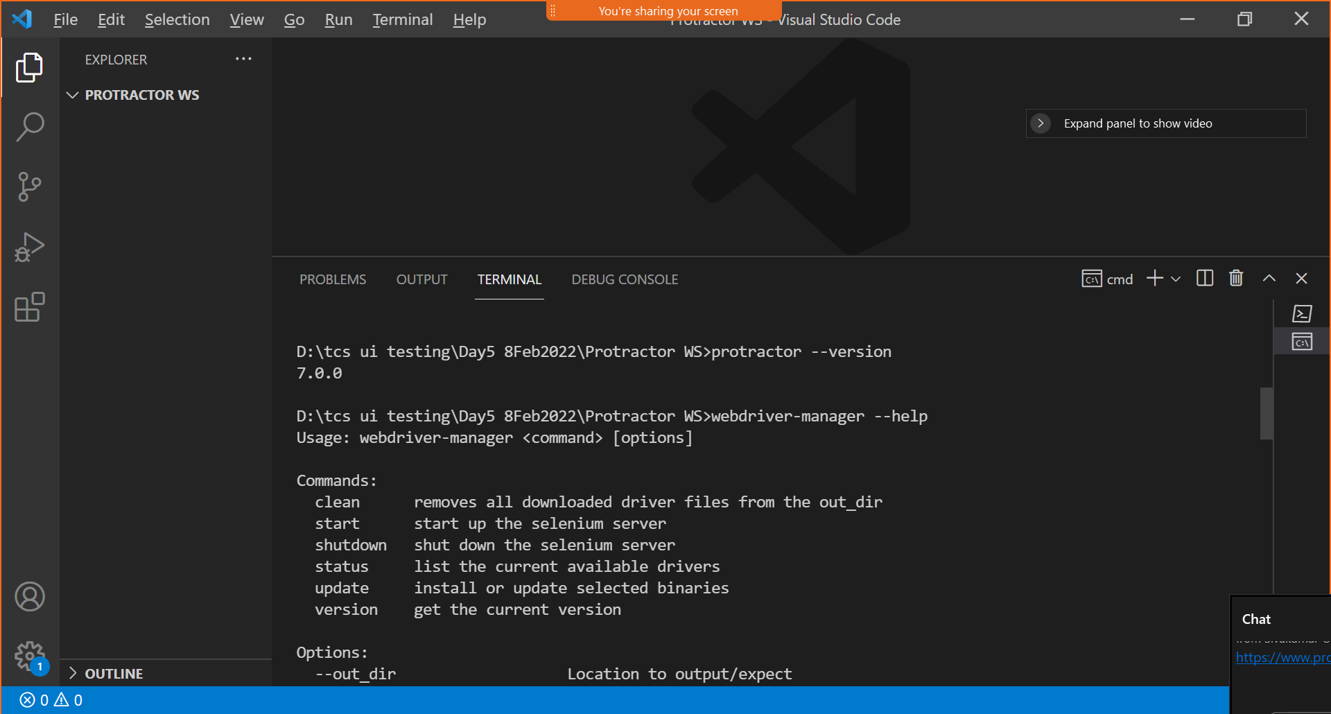

1. To Check the version of WebDriver Manager installed, run the following command

Webdriver-manager version

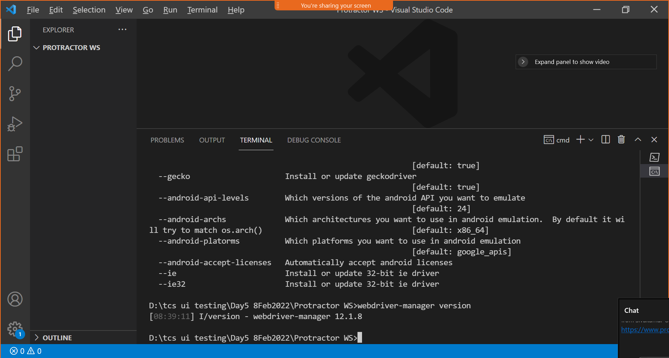

1. To check all the installed drivers by webdriver-manager, run the following command

Webdriver-manager status

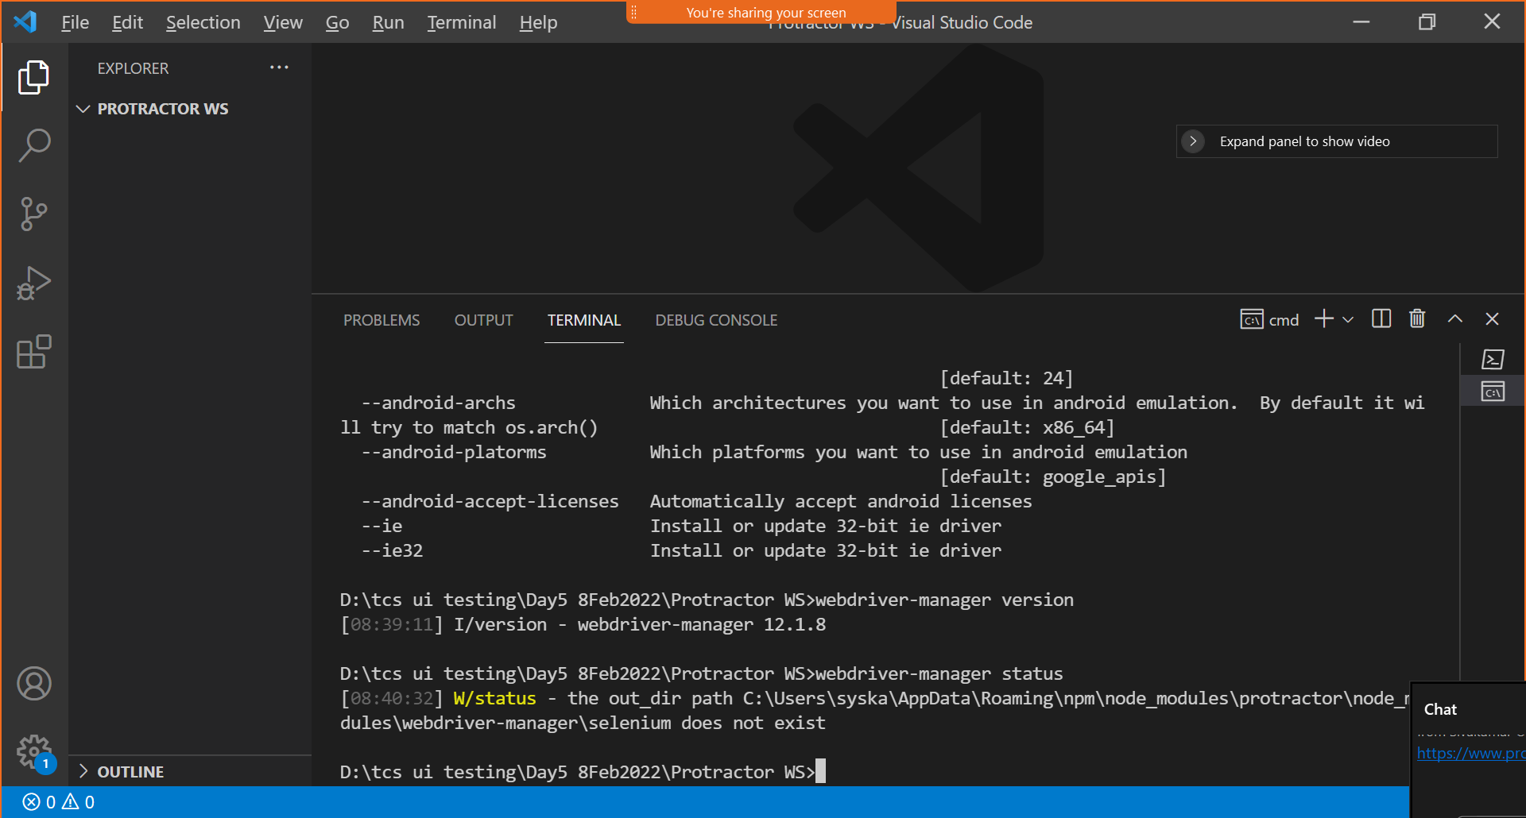

1. To Install/update browser drivers, use the following command

Webdriver-manager update

1. Executing the update command will download/update existing webdrivers

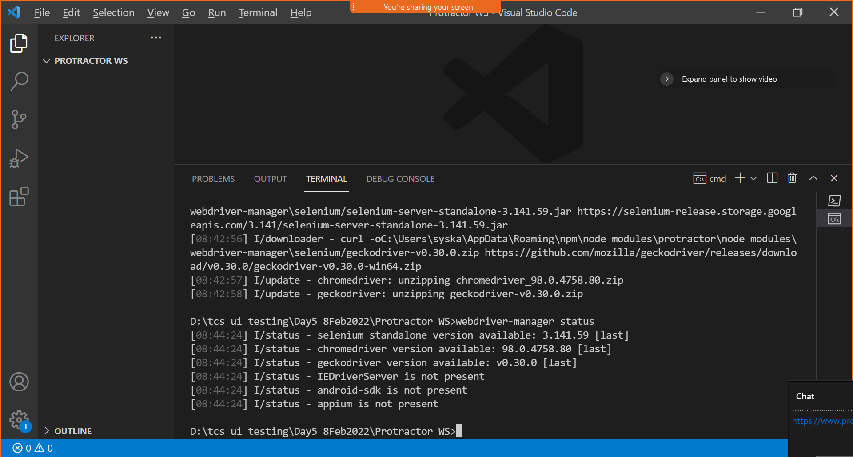

The location where webdriver-manager will maintain the all the driver related files

C:\Users\syska\AppData\Roaming\npm\node_modules\protractor\node_modules\webdriver-manager\selenium

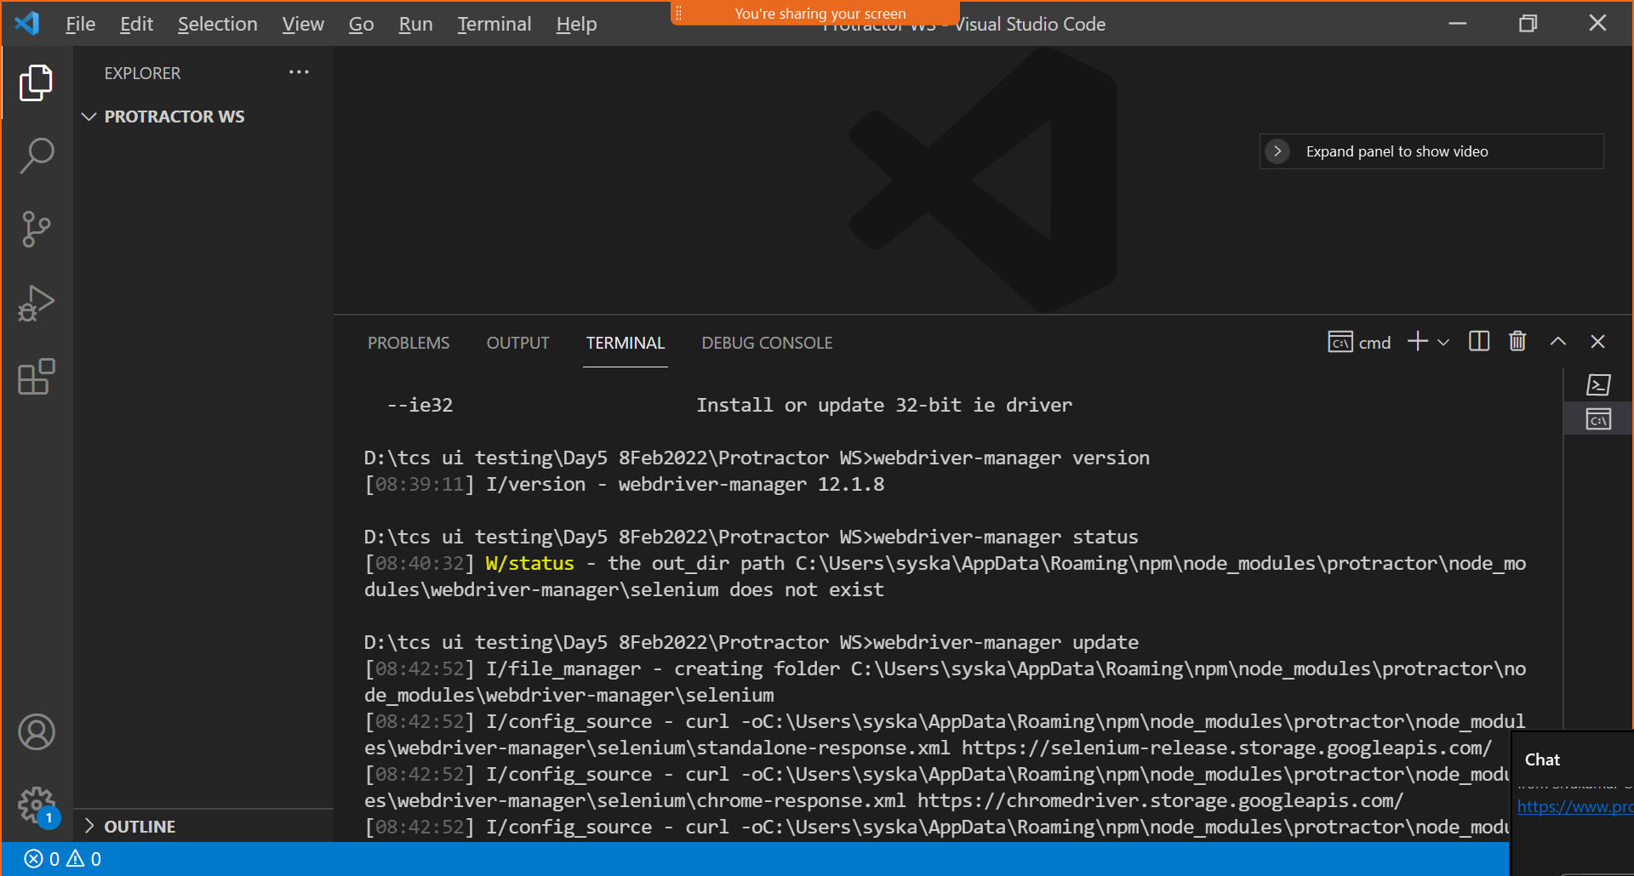

1. We have successfully installed protractor and updated all the webdrivers using webdriver-manager
2. Start the selenium server by running the following command

Webdriver-manager start

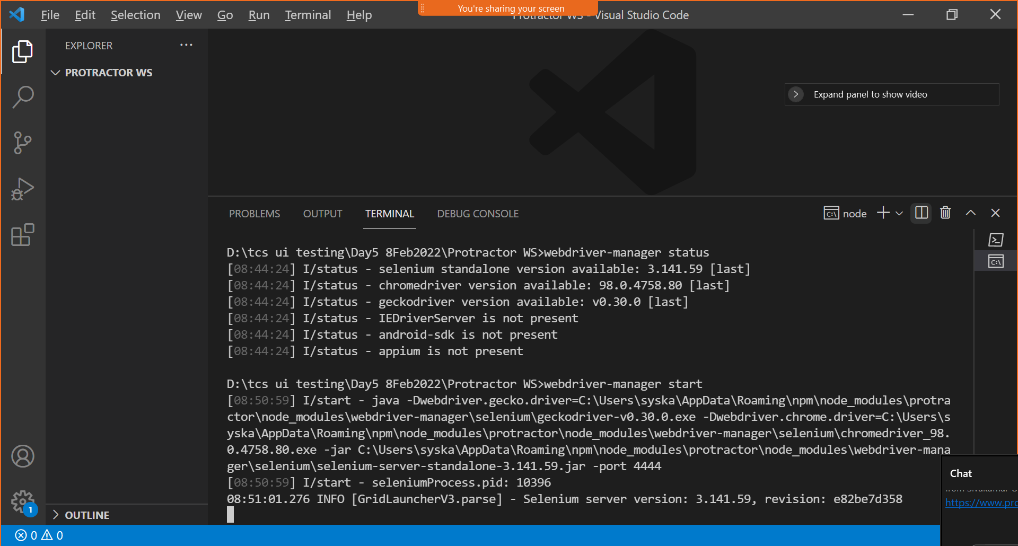

1. Writing the first e2e test
2. Use the existing todo app which is available in the angularjs.org

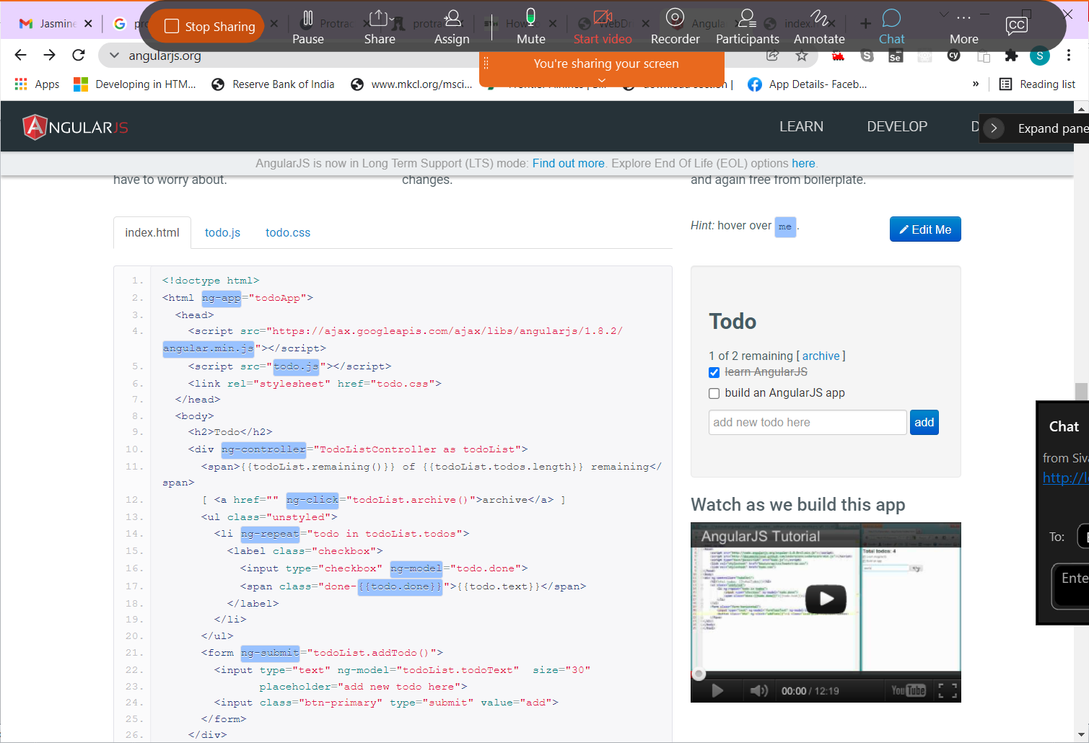

1. Copy index.html, todo.js,todo.css file in the current folder and add todo-spec.js and conf.js from protractor official document.

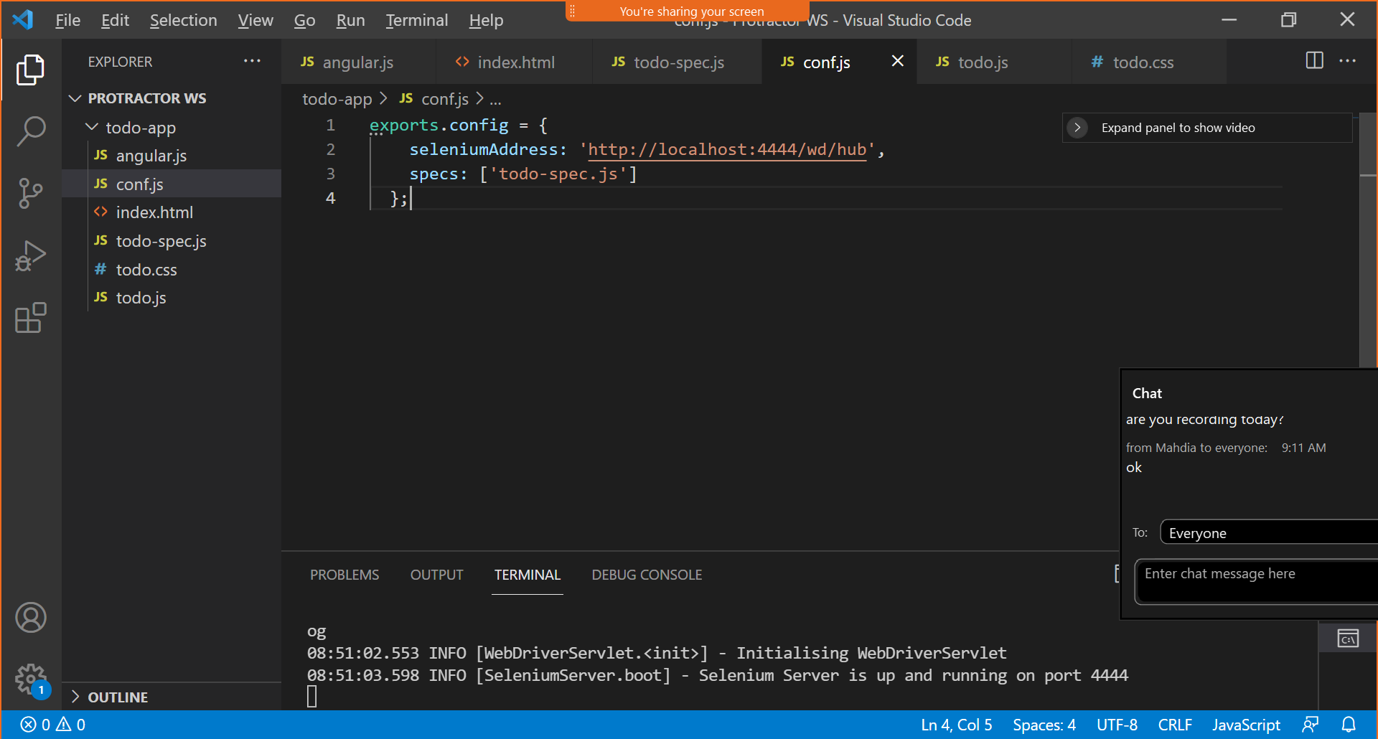

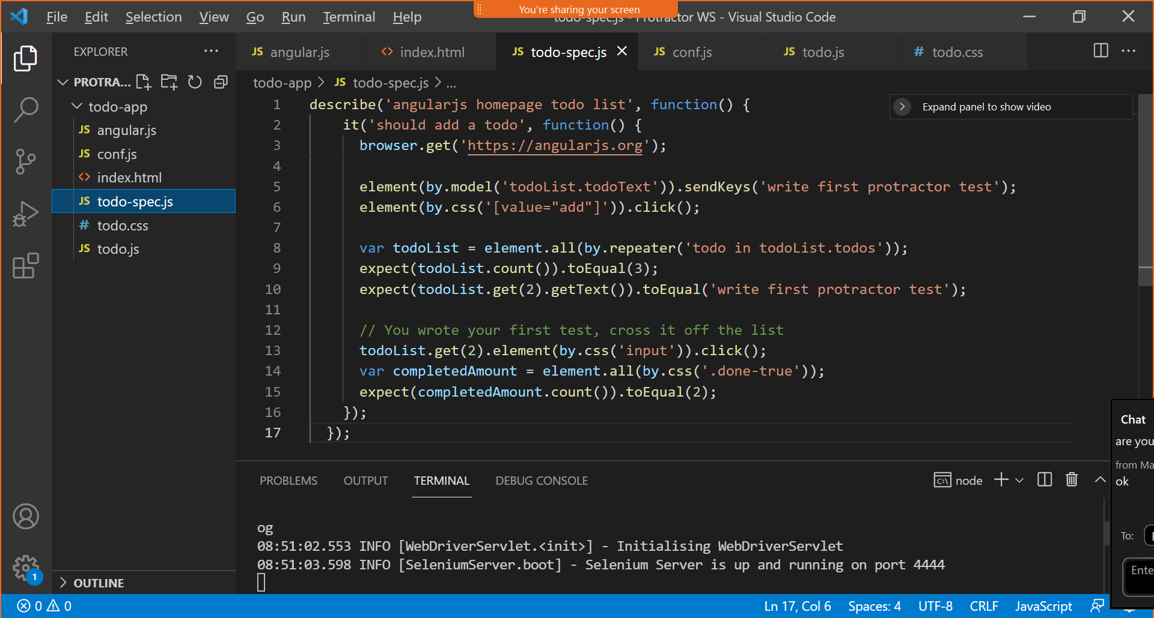

<http://juliemr.github.io/protractor-demo/>

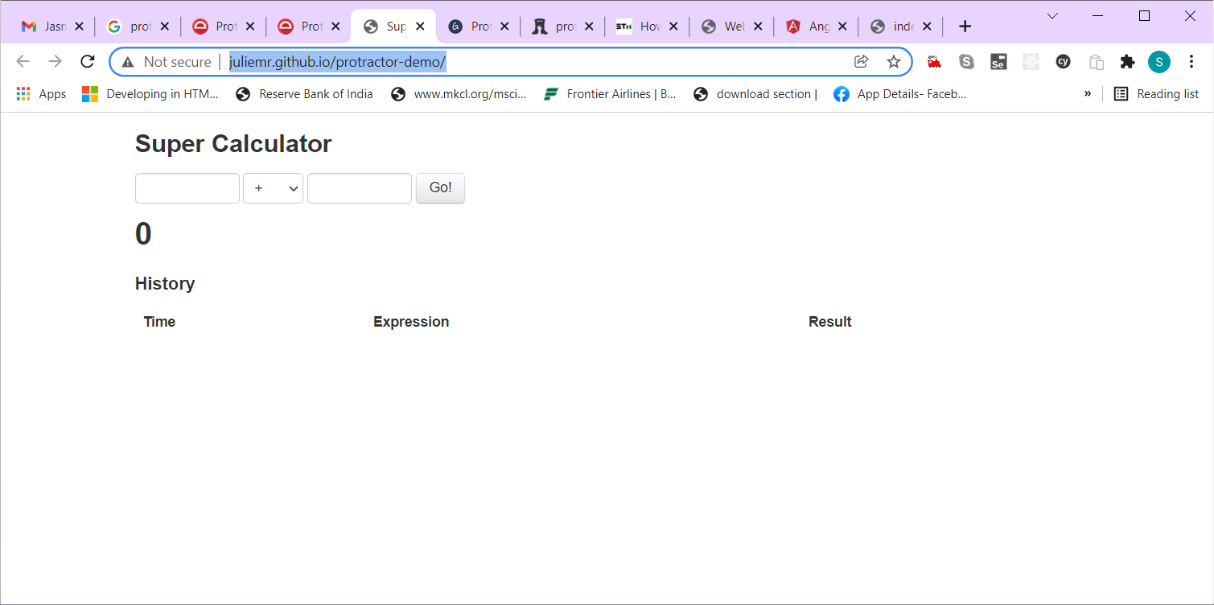

Protractor Source Code - <https://github.com/angular/protractor>

JAVA_HOME = C:\Program Files\Java\jdk1.8.0_301

Download JDK1.8 = <https://www.oracle.com/java/technologies/downloads/#java8-windows>

Path = %JAVA_HOME%\bin

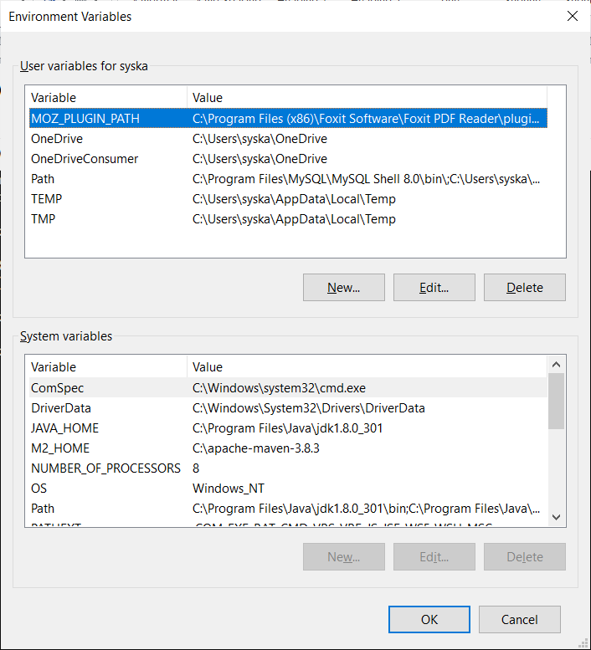

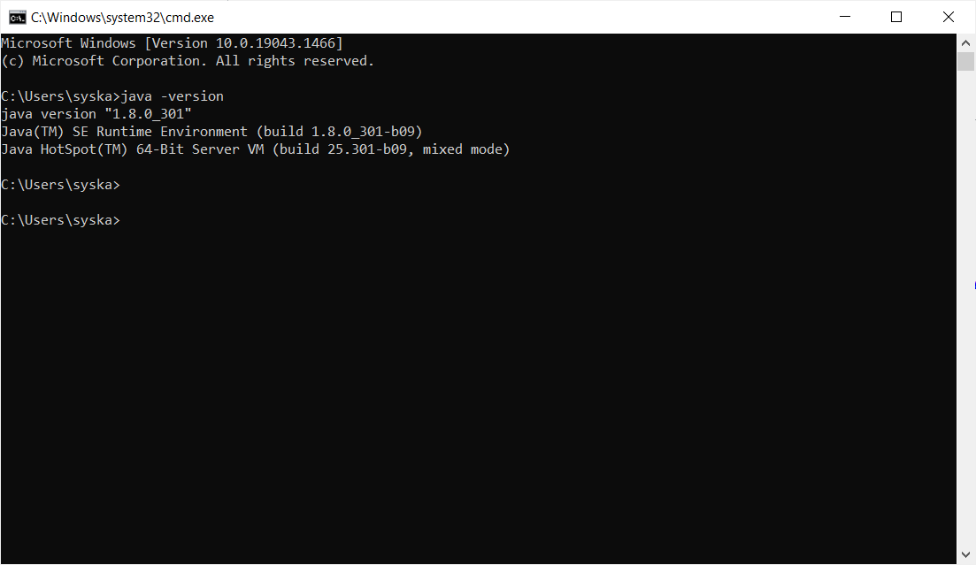

Add few more e2e test cases for tour of heroes app.

1. A test case to check total number of heroes listed
2. A test case to check number of heroes visible in dashboard
3. A test case to add a new hero with the name “AntMan”
4. A test case to update “AntMan” to “SpiderMan”
5. A test case to delete “SpiderMan”